Project Documentation
MuseSense: Tangible + Gesture + Face Interactive Museum Guide (HCI Project)
1) Project Summary
MuseSense is an interactive museum experience where visitors explore exhibits using TUIO tangible markers (physical cards/tokens placed on a table), hand gestures (to curate lists and control views), and facial expression analysis (for login + emotion-aware personalization).
Visitors can:
- Place a tangible marker representing an artifact/exhibit on an interactive surface to instantly view it in 2D/3D with media, context, and recommendations.
- Use hand gestures to quickly save items into personal lists: Favorites, Explore Later, and Good to See.
- Log in / register using face-based identity verification, and optionally enable emotion-aware personalization where the system uses their facial expression (e.g., happiness) and perceived engagement to recommend categories.
Goal: Improve engagement, reduce friction in navigation, and make exploration playful and accessible using multi-modal HCI interaction.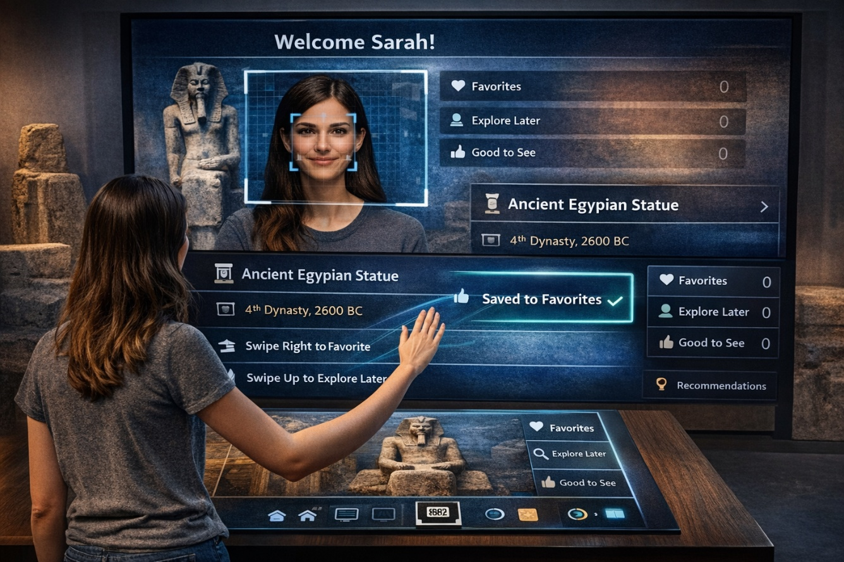
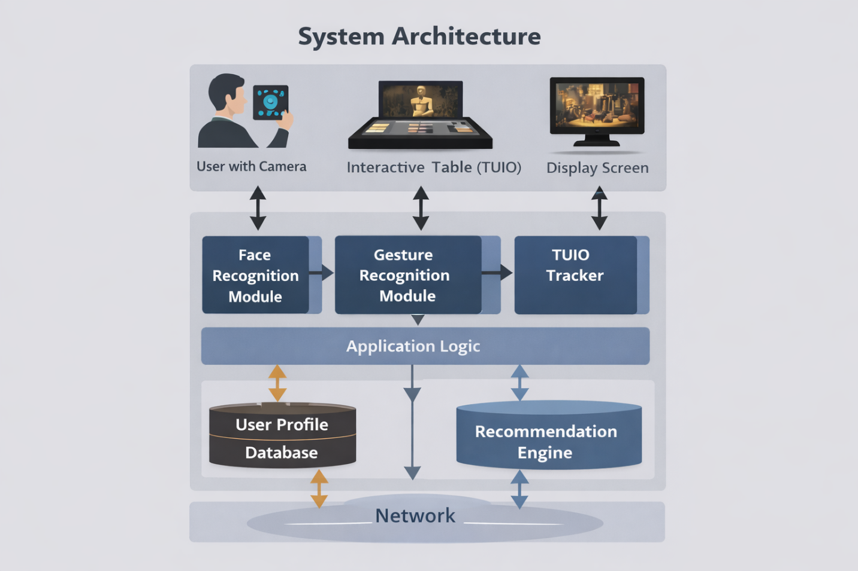
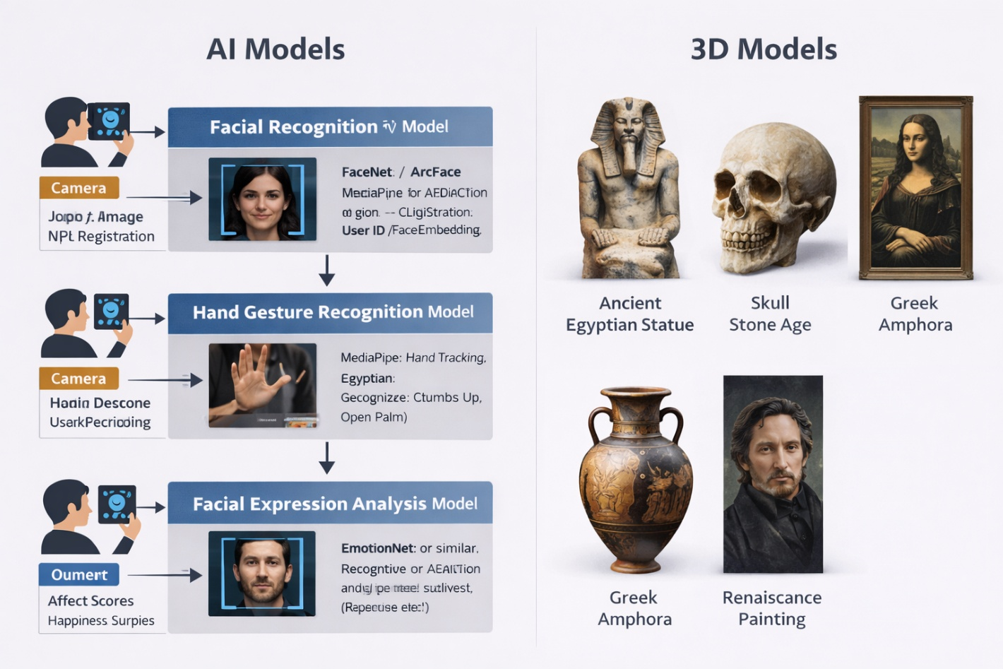
2) Course Requirements Coverage
Requirement A — TUIO Markers
- Each artifact has a printed marker/token.
- When placed on the interactive table, the system detects the marker via TUIO protocol and loads artifact content.
- Moving/rotating the token changes the view (e.g., rotate to rotate a 3D model, slide to scrub timeline).
Requirement B — Facial Expression
- Used for login/register (face recognition/verification).
- Used optionally for emotion signals:
  - Detect happiness/interest cues while viewing artifacts.
  - Support “mood-aware recommendations” and “engagement score” per category.
Requirement C — Hand Gestures
- Gesture-based actions:
  - Swipe Right: Save to Favorites
  - Swipe Up: Add to Explore Later
  - Pinch: Zoom artifact image/model
  - Open Palm: Return Home / Hide panels
  - Thumbs Up: “Good to See” (quick positive marker)

3) Problem Statement
Traditional museum experiences can be:
- Passive (read-only labels)
- Overwhelming (too many artifacts, limited personalization)
- Slow to navigate (menus, scanning QR, typing searches)
MuseSense solves this by providing a natural interaction system that is:
- Physical (tangible tokens)
- Expressive (gesture control)
- Personal (face login + emotion-aware recommendations)

4) Objectives (HCI-Oriented)
- Reduce Interaction Friction
Replace complex menus with physical tokens and gestures.
- Increase Engagement & Enjoyment
Encourage playful exploration and curiosity-driven browsing.
- Support Personalization
Visitor profiles store preferences and generate recommendations.
- Make Interaction Learnable and Accessible
Provide clear affordances, guided hints, and alternative actions.

5) Target Users & Personas
Persona 1: “Casual Visitor”
- Wants quick, fun exploration.
- Doesn’t want to type or read long text.
- Benefit: tokens + gesture saves + short summaries.
Persona 2: “Student Researcher”
- Wants deep context and ability to collect items.
- Benefit: saved lists, categories, history, export notes (optional feature).
Persona 3: “Family / Group”
- Wants interactive playful experience.
- Benefit: multi-user mode and “group favorites” (optional feature).

6) Core Features
6.1 Tangible Artifact Exploration (TUIO)
Interaction
- Place artifact marker → artifact page opens
- Rotate token → rotate 3D model / image
- Move token closer/farther → zoom or switch detail level
Output
- Artifact title, era, story, fun facts
- 3D preview or image carousel
- Related artifacts (“Similar style / period / artist”)

6.2 Face Login / Registration + Expression Awareness
Login/Register
- Visitor stands in front of the kiosk camera.
- Face is used to authenticate and load personal profile.
Expression Awareness (Opt-in)
- While viewing artifacts, the system measures “positive affect” signals (e.g., smiles).
- It updates a lightweight “interest score” per category.
Important HCI note: This must be presented as optional with consent and privacy notice.

6.3 Gesture-Based List Curation
Each user has 3 sets:
- Favorites: “I love this”
- Explore Later: “I want to revisit”
- Good to See: “Worth recommending / nice”
Gestures
- Swipe right → Favorites
- Swipe up → Explore Later
- Thumbs up → Good to See
- Pinch → zoom
- Open palm → back/home
Feedback
- Clear visual confirmations: icon + short toast (“Saved to Favorites ✅”)
- Undo gesture/button for safety

7) Additional Features (Recommended to Strengthen the Project)
These are great for HCI grading because they add usability, accessibility, and evaluation depth:
Feature 1 — Guided Onboarding (“How to Use” Overlay)
- First-time users see a 20–30 second tutorial with animations:
  - “Place token here”
  - “Swipe to save”
  - “Rotate token to rotate the artifact”
Feature 2 — Multi-User Mode (Two Visitors at One Table)
- Support two profiles by:
  - two camera zones, or
  - “tap your profile token” to switch active user
- Split screen or color-coded UI.
Feature 3 — Accessibility Mode
- Gesture alternatives as on-screen buttons.
- Larger text mode.
- High-contrast mode.
- Audio narration (optional).
Feature 4 — “Museum Trail / Quest”
- The system builds a personalized trail: “5 artifacts you’ll love”
- It uses your saved lists + engagement signals.
Feature 5 — Takeaway Summary (Export)
- At the end, generate a QR code for the visitor:
  - their favorites list
  - short descriptions
  - recommended next exhibits
(Export feature is very attractive in demos.)

8) System Functional Requirements
FR1 — Marker Detection (TUIO)
- System shall detect marker ID, position, and rotation.
- System shall load the artifact mapped to marker ID within ≤ 1 second.
FR2 — Artifact View
- System shall display artifact media and metadata.
- System shall support 2D/3D view mode switching.
FR3 — Gesture Recognition
- System shall recognize at least 5 gestures reliably.
- System shall provide real-time feedback for recognized gestures.
FR4 — User Profile
- System shall create and store profiles.
- System shall save lists (Favorites, Explore Later, Good to See).
- System shall maintain viewing history.
FR5 — Face Login + Opt-in Emotion
- System shall support face-based login/verification.
- System shall require consent before enabling expression-based personalization.

9) Non-Functional Requirements
- Usability: learnable within 2 minutes for first-time users
- Responsiveness: 30 FPS tracking (if possible), low latency feedback
- Privacy: store minimal biometric data, consent + delete option
- Reliability: graceful fallback when face/gesture fails
- Security: encrypted storage for user profiles (if networked)

10) Interaction Design
10.1 Main User Flow
- Welcome Screen
- Face Login/Register
- Explore Mode
  - Place marker to open artifact
  - Gesture to save to lists
- Recommendations
  - Based on lists + optional expression signals
- End Session
  - summary + optional QR export
10.2 Key Screens
- Welcome / Consent
- Login/Register
- Artifact Viewer
- Lists Dashboard
- Recommendations / Trail
- Session Summary
10.3 Feedback & Error Prevention
- Every recognition action must show:
  - Visual feedback (highlight marker, gesture icon)
  - Audio or haptic (optional)
- Misrecognition handling:
  - “Undo” option for saves
  - “Try again” prompt for face login
  - fallback buttons for list actions

11) Data Model (Conceptual)
User
- userId
- faceTemplateHash (or embedding if used)
- consentFlags (faceAuth, emotionPersonalization)
- favorites[]
- exploreLater[]
- goodToSee[]
- categoryScores { ancient, modern, sculpture, … }
Artifact
- artifactId
- name, era, category, description
- media (images, 3D model)
- tuioMarkerId
Events (for analytics/evaluation)
- markerPlaced, markerRemoved
- gestureRecognized
- listAdd/listRemove
- sessionDuration
- recommendationClicks

12) Technical Implementation Plan (High-Level)
12.1 Hardware Setup
- Camera above table (marker + gesture tracking)
- Optional separate camera for face login kiosk (or same camera with different mode)
- Large screen or projector display
12.2 Suggested Software Stack (Example)
- TUIO tracking: reacTIVision / any TUIO server + your client app
- Client UI: Web app (React) or Unity
- Gesture + Face: MediaPipe + face expression model (or OpenCV-based pipeline)
- Backend: Node.js + MongoDB (optional; local-only storage also possible)
For a course project, you can implement everything locally and simulate backend with JSON storage if needed.

13) Ethics, Privacy, and Consent
Because face data is sensitive:
- Show a consent screen clearly stating:
  - what is collected (face for login, expression for personalization)
  - why it’s collected
  - where it’s stored
  - delete option
- Provide “Continue as Guest” mode:
  - no face storage
  - only temporary session lists

14) HCI Evaluation Plan
14.1 Study Design
- Participants: 8–15 users (students/friends)
- Tasks:
  - Log in / continue as guest
  - Explore 3 artifacts using markers
  - Save 1 item to each list using gestures
  - Find and open favorites list
  - Follow one recommendation
14.2 Metrics
- Task completion rate (%)
- Time on task (seconds)
- Error rate (misrecognition, wrong list)
- Learnability (time to first correct gesture)
- Satisfaction (SUS questionnaire or 1–5 Likert)
- Qualitative feedback (short interview)
14.3 Expected Findings
- Tangible interaction improves discoverability.
- Gesture saves reduce menu navigation time.
- Face login reduces typing, but requires clear consent + fallback.

15) Project Milestones (Suggested 4–6 Weeks)
- Week 1: Requirements + UI wireframes + marker mapping
- Week 2: TUIO integration + artifact viewer
- Week 3: Gesture recognition + list curation
- Week 4: Face login + profile storage
- Week 5: Recommendations + onboarding + accessibility
- Week 6: Evaluation + report + demo polishing

16) Risks & Mitigation
- Gesture misrecognition → add fallback buttons + simpler gesture set
- Lighting issues for markers → controlled lighting + calibration
- Face privacy concerns → guest mode + opt-in + delete profile
- Complexity creep → lock MVP early (TUIO + 3 gestures + basic login)

17) MVP Definition (What You Must Deliver)
Minimum to satisfy the course requirements cleanly:
- TUIO markers load artifacts (at least 6 artifacts)
- Face login/register OR guest mode (but face must be implemented)
- 5 gestures: swipe right/up, pinch, open palm, thumbs up
- Lists: Favorites / Explore Later / Good to See
- Basic recommendations by category

